Title: Curriculum Enhancement using Analog Discovery Boards  
Author: Dinh Tran  
  
Department: Electrical and Computer Engineering  
University: Seattle University

### Abstract

Since the online learning coming to be major role in 2020 which will disconnect the student from the real lab environment. So, this research is making to help student participate on IoT lab experiment with little to no effort circuit knowledge requirement and small demo of visible light communication.

### Background

Thing Speak is a cloud database platform that easy send and get data with real time and a medium to connected by many devices.

### Procedure

#### Components:

|  |  |
| --- | --- |
| Unit | Quantity |
| Analog Discovery part kits | 1 |
| Digilent Portable analog circuit design kit | 1 |
| MATLAB application | 1 |
| 470 Ohm resistor | 1 |
| 10k Ohm resistor | 2 |
| 100 Ohm resistor | 2 |
| 1k Ohm resistor | 1 |
| 5k Potentiometer | 1 |
| 39pF capacitor | 1 |
| 47nF capacitor | 1 |
| 22uF capacitor | 2 |
| 10uF capacitor | 1 |
| 1N3064 Diode | 1 |
| Speaker | 1 |
| Microphone (ADMP504) | 1 |
| AD8226 Op-amp | 1 |
| AD8541 OP-amp | 1 |
| LED | 1 |
| Solar panel | 1 |

#### Circuit Schematic:

This lab is included with 2 differences project, but it could use the same audio analog op-amp with the potentiometer for changing the resistor to get the clearest sound output possible. Please note the label of the on-board connection because that is the same label as analog discovery output label.

Figure 1: Schematic of microphone connection with analog discovery and bread board:

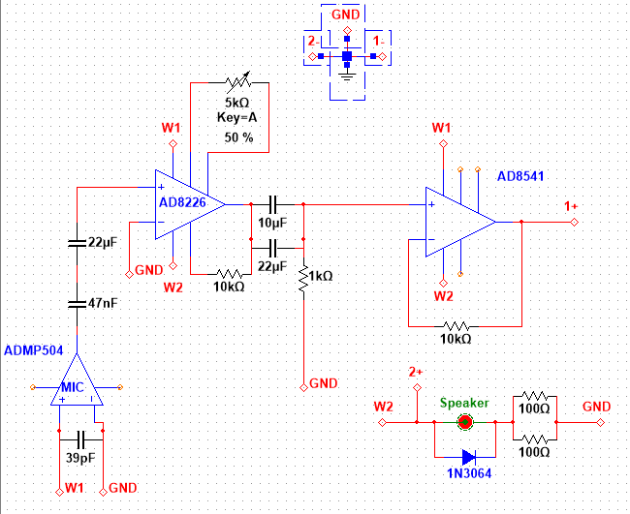

Figure 2: Schematic of visible light communication with analog discovery:

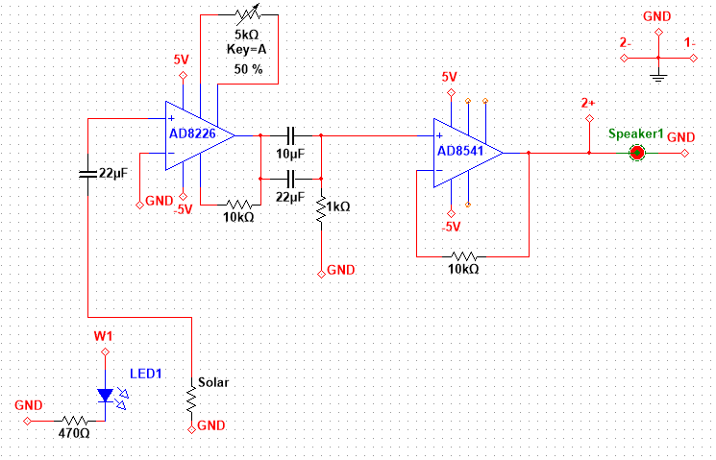

#### Set up

##### Microphone setup

Choose out all the components that we need in the circuits. Then place on the breadboard with the same connection as schematic as shown in figure 1.

|  |  |
| --- | --- |
| Label | Cable color |
| 1+ | Orange |
| 1- | Orange with white |
| 2+ | Blue |
| 2- | Blue with white |
| W1 | Yellow |
| W2 | Yellow with white |

Good tips for this setup is use bigger board which have 4 difference power rail or use 2 small breadboard.

When you finish connecting everything to breadboard if you new to analog discovery go to Appendix A for setting up the analog discovery with MATLAB.

When finish it, at the top utilities box, open the new Script. Copy the code below to connect the DIGILENT analog discovery (make sure the USB is connected).

daqlist("digilent")

dq = daq("digilent")

then set up the output and input signal to the Digilent analog discovery

addoutput(dq, "AD1", "1", "Voltage");

addoutput(dq, "AD1", "2", "Voltage");

ch_out = dq.Channels(1:2);

ch_out(1).Name = "AD1_1_out";

ch_out(2).Name = "AD1_2_out";

addinput(dq, "AD1", "1", "Voltage");

addinput(dq, "AD1", "2", "Voltage");

ch_in = dq.Channels(3:4);

ch_in(1).Name = "AD1_1_in";

ch_in(2).Name = "AD1_2_in";

After that setting the output frequency and define the output frequency (Note: Since the Digilent package support is not a fully supported of data Acquisition class in MATLAB, so the output frequency needs to set by using Fourier’s Theorem to generate wave signals.)

rate = 300e3;

dq.Rate = rate;

% Specify a 1000 Hz sine wave for 15 second.

f = 1000000;

totalduration = 15;

n = totalduration * rate;

t = (1:n)/rate;

output = 4.5*cos(0*pi*f*t)';

disp('Mic on')

[data, startTime] = readwrite(dq, [output -1*output]);

* NOTE: f is frequency; totalduration is amount of time that send signal out. the longer the duration the better result.

** NOTE: don’t use max output aka 5V because it is will cause error since the gain is high.

The code below is to read the input data and plot out to matlab figure:

subplot(2,2,1);

plot(data.Time, data.AD1_1_in);

subplot(2,2,2);

plot(data.Time, data.AD1_2_in);

Now for the output for speaker:

disp('speaker')

[data, startTime] = readwrite(dq, [output data.AD1_1_in]);

subplot(2,2,2);

plot(data.Time, data.AD1_2_in);

Now to next step of setting up. Now Set up Think speak data base to MATLAB.

1. Go to <https://thingspeak.com/> then create an account there.
2. Then click on new channel and create new channel.
3. In the channel just create click on API keys. Copy the API key and channel ID
4. Then back to MATLAB add-on download and install “ThinkSpeak Support ToolBox”
5. After that copy the code below to send data to ThinkSpeak.

thingSpeakWrite(IDs,temperature,'WriteKey',APIkey);

*For the full code, please check the Appendix B.

##### Visible light communication set-up

With the same color code as the microphone set-up, build the circuit the same as schematic in figure 2. Make sure the LED is about 3 cm apart of solar sensor. The further the solar sensor the lower the sound can have.

This time download WaveForms from this link below:

<https://store.digilentinc.com/waveforms-download-only/>

choose your operation then download and install to your computer.

After finish install, open the waveforms application with analog discovery connected to your PC/MACS and open 3 window (Scope, Wavegen, and Suppies) as figure 3

Figure 3: Waveforms window

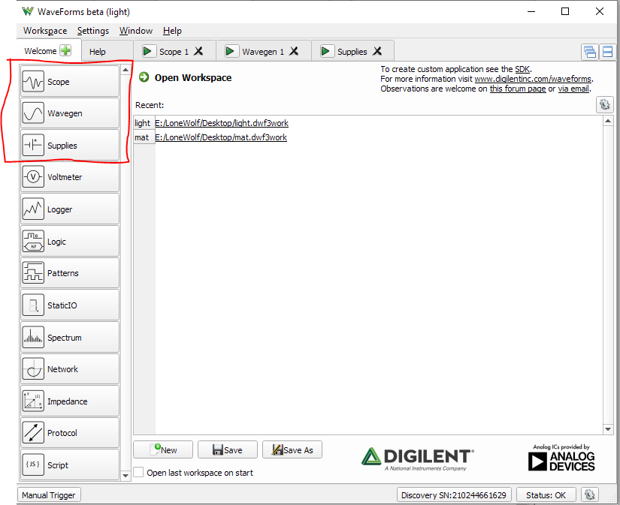

Go to Scope windowset channel 1 range to 500 mV/div and channel 2 range to 1V/div. At time window change base to 100ms/div.

Figure 4: Picture to check if the same setting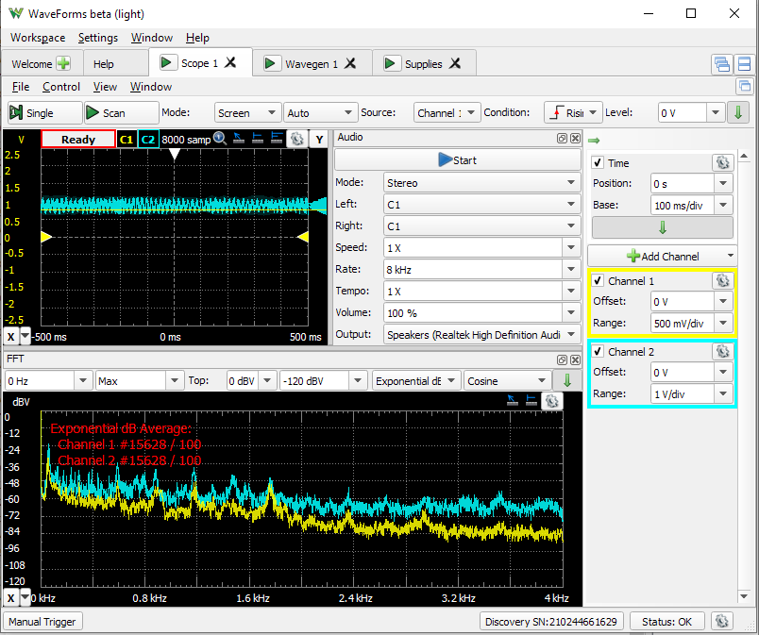

Then go click view and click FFT and audio. Such as figure 5

Figure 5: for better visualization

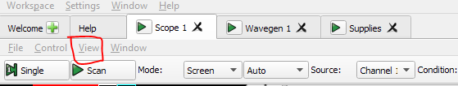

In audio window set rate to 8kHz. And as prefer, you can set mono or stereo mode.

After finish above, go to wavegen window, click on simple (next to the run button) figure below for better visualize.

Figure 6: wavegen setting

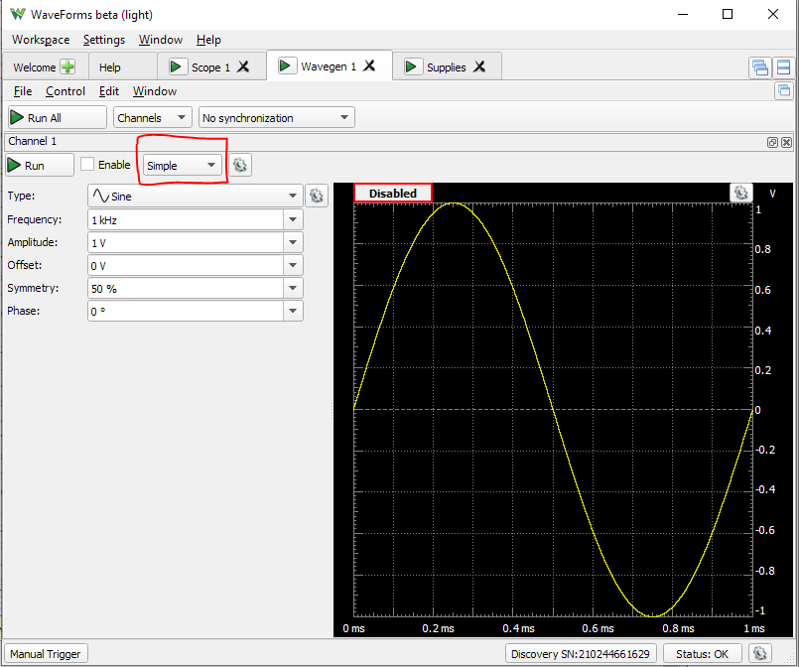

Change to play option. Then decide what you want to play by using import button and choice your prefer audio. Import everything with default setting. When finish, change amplitude to 500mV (I will say the reason below) and offset is 2V.

After that, the set-up is pretty much finish and ready to power on. You can enjoy with the speaker that provide or your pc/mac speaker by click play in the scope (the scope set-up must be the same as figure 4 to have the best audio)

*NOTE: There is 3 major impact to the audio quality in this set up. The brightness of the room, the location of the solar panel and the amplitude in the wavegen setting. So be sure to put the room brightness lower for better connection.

### Results

After the data was collected from circuits, it push the data to thinkspeak.

### Discussion

There are still a huge disadvantage of Analog discover kits which is the limited of output voltage from -5V to 5V and input voltage is from -25V to 25 V. In case of using op-amp and any parts that need more than 5V then we need to make voltage booster to increase to desire voltage.

For sending to thinkspeak, because thingspeakonly take maximum 1 bit of data which is 256 point at 1 and at this generation we have more than 100000 data point so the only thing we can put up is sound level dB. and I still finding the way to make dBV to SPL so it can show how loud sound is being record.

For visible light communication it is really depend on how the analog discovery output can handle because the offset is to have the LED turn on and the amplitude of the signal sending while it add up should be lower than the maximum output of the analog discovery.

### Appendix A

Open MATLAB application and on the top utilities bar (figure 3) and click on Add-on then get Add-on (home >> Add-on >> get Add-on). The Add-on window will pop up (figure 4).

Figure 3: utilities bar



Figure 4: Add-on pop-up window

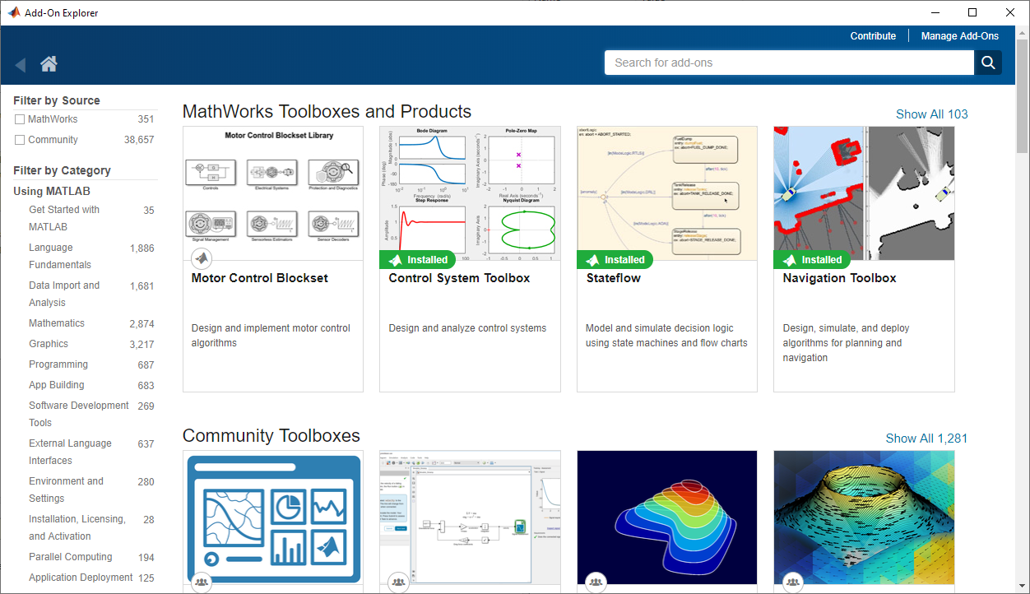

At the search box on the type in “Data Acquisition Toolbox Support Package for Digilent Analog Discovery” then download and install it.

### Appendix B

clc;

clear;

%% Discovery Digilent Device

% Discover Digilent devices connected to your system using |daqlist|

daqlist("digilent")

%% Create a DataAcquisition for a Digilent Device

% Discover Digilent devices connected to your system using |daqlist|

dq = daq("digilent")

%% Add an Analog Output Channel

% Add an analog output channel using the listed Digilent device with ID

% |AD1|, channel ID |1|, and measurement type |Voltage|.

addoutput(dq, "AD1", "1", "Voltage");

addoutput(dq, "AD1", "2", "Voltage");

ch_out = dq.Channels(1:2);

ch_out(1).Name = "AD1_1_out";

ch_out(2).Name = "AD1_2_out";

%% Add an Analog Input Channel

% Add an analog input channel with the same device and measurement type

% |Voltage|.

addinput(dq, "AD1", "1", "Voltage");

addinput(dq, "AD1", "2", "Voltage");

ch_in = dq.Channels(3:4);

ch_in(1).Name = "AD1_1_in";

ch_in(2).Name = "AD1_2_in";

rate = 300e3;

dq.Rate = rate;

% Specify a 1000 Hz sine wave for 15 second.

f = 1000000;

totalduration = 15;

n = totalduration * rate;

t = (1:n)/rate;

output = 4.5*cos(0*pi*f*t)';

disp('Mic on')

[data, startTime] = readwrite(dq, [output -1*output]);

subplot(2,2,1);

plot(data.Time, data.AD1_1_in);

subplot(2,2,2);

plot(data.Time, data.AD1_2_in);

%% Speaker

disp('speaker')

[data, startTime] = readwrite(dq, [output data.AD1_1_in]);

subplot(2,2,2);

plot(data.Time, data.AD1_2_in);

%%

audio = fft(data.AD1_1_in);

L = length(audio);

freq = linspace(rate/L,rate/2,L/2);

Amp2 = abs(audio/L);

Amp1 = 2*Amp2(2:L/2+1);

dBAmp1=20*log10(Amp1);

subplot(2,2,3);

stem(freq, Amp1);

subplot(2,2,4);

stem(freq, dBAmp1);